**REACT 04**

**AIM:** Create a new react application using *create-react-app* tool with the name as “blogapp”

**Program:**

**Post.js:**

import React, { Component } from 'react';

import PostCard from './PostCard';

import './styles/blogstyle.css';

class Posts extends Component {

  constructor() {

    super();

    this.state = {

      posts: [],

      hasError: false

    };

  }

  componentDidMount() {

    this.fetchPosts();

  }

  fetchPosts = () => {

 fetch('https://jsonplaceholder.typicode.com/posts?_limit=6')

      .then((res) => res.json())

      .then((data) => this.setState({ posts: data }))

      .catch((err) => this.setState({ hasError: true }));

  };

  componentDidCatch(error, info) {

    alert('Something went wrong while displaying posts.');

    console.error(error, info);

  }

  render() {

    const { posts, hasError } = this.state;

    if (hasError) {

      return <p className="error-box">🚨 Could not load blog posts.</p>;

    }

    return (

      <div className="blog-wrapper">

        <header className="blog-header">

          <h1>🧠 BlogSphere</h1>

          <p>Where ideas take shape...</p>

        </header>

        <section className="post-grid">

          {posts.map((post) => (

            <PostCard key={post.id} title={post.title} body={post.body} />

          ))}

        </section>

      </div>

    );

  }

}

export default Posts;

**Posts.js:**

import React from 'react';

import './styles/blogstyle.css';

const PostCard = ({ title, body }) => {

  return (

    <div className="post-bubble">

      <div className="post-content">

        <h3>{title}</h3>

        <p>{body}</p>

      </div>

    </div>

  );

};

export default PostCard;

**APP.js:**

import React from 'react';

import './styles/blogstyle.css';

import Posts from './Posts';

function App() {

  return (

    <div className="App">

      <Posts />

    </div>

  );

}

export default App;

**blogstyle.css:**

body {

  margin: 0;

  background: radial-gradient(circle at 30% 20%, #1f4037, #99f2c8);

  font-family: 'Trebuchet MS', sans-serif;

  color: #fff;

}

.blog-wrapper {

  padding: 2rem;

}

.blog-header {

  text-align: center;

  margin-bottom: 2rem;

}

.blog-header h1 {

  font-size: 2.8rem;

  margin: 0;

  color: #f9ed69;

  text-shadow: 2px 2px 3px rgba(0, 0, 0, 0.3);

}

.blog-header p {

  font-style: italic;

  color: #eee;

}

.post-grid {

  display: grid;

  grid-template-columns: repeat(auto-fit, minmax(280px, 1fr));

  gap: 1.5rem;

}

.post-bubble {

  background: rgba(255, 255, 255, 0.1);

  border-left: 5px solid #f38181;

  border-radius: 15px;

  padding: 1rem;

  transition: all 0.3s ease;

  box-shadow: 0 4px 10px rgba(0, 0, 0, 0.2);

}

.post-bubble:hover {

  background-color: rgba(255, 255, 255, 0.2);

  transform: scale(1.02);

}

.post-content h3 {

  margin-top: 0;

  color: #fce38a;

}

.post-content p {

  color: #fff;

  line-height: 1.6;

}

.error-box {

  background: #ff6f61;

  padding: 1rem;

  border-radius: 10px;

  text-align: center;

  max-width: 600px;

  margin: 50px auto;

  color: white;

  font-weight: bold;

}

**OUTPUT 01:**

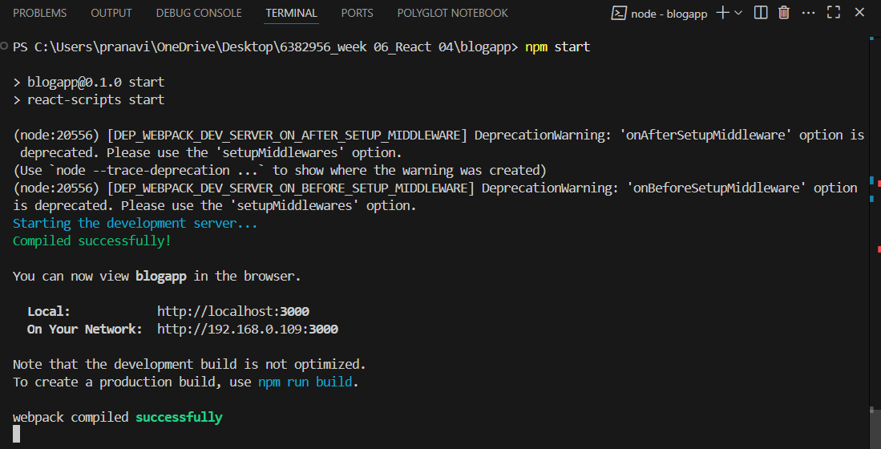

OUTPUT 02:

